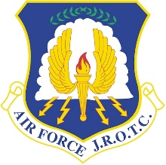
Unit General Knowledge Packet
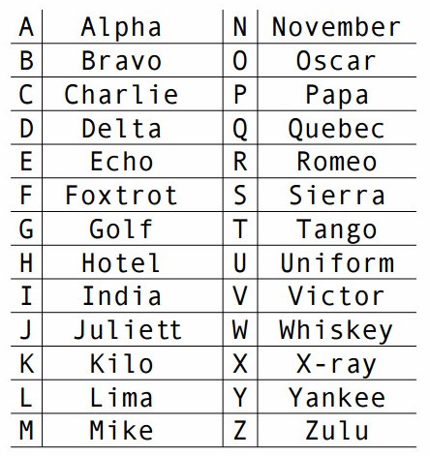
Essential Knowledge
AFJROTC: Air Force Junior Reserve Officer Training Corps
Air Force DoB: September 18, 1947
Air Force colors: Ultramarine blue and yellow
Air Force Mission Statement: To fly fight and win… airpower, anytime, anywhere!
Air Force Units: 3+ Cadet > 2+ Element > 2+ Flight > 2+ Squadron > 2+ Group > Wing > Numbered Air Force > Major Command
Uniform guidance: DAFI36-2903
The 6 Branches of the Military: Air Force, Army, Coast Guard, Marines, Navy, Space Force
Original 13 Colonies: Connecticut, Delaware, Georgia, New Hampshire, New Jersey, New York, North Carolina, Maryland, Massachusetts, Pennsylvania, Rhode Island, South Carolina, Virginia
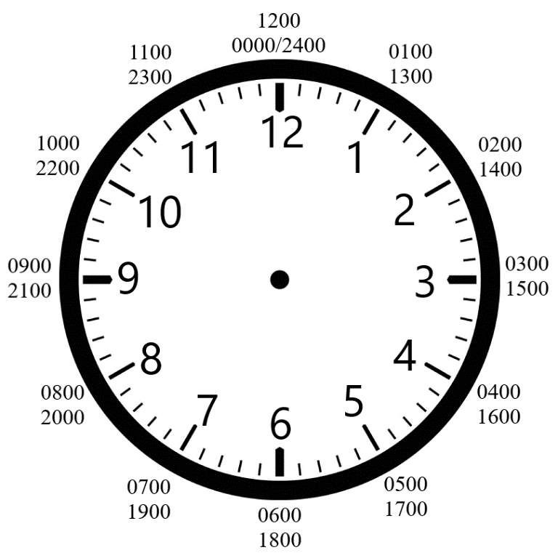
Opening Statement: Sir/Ma’am good morning/afternoon sir/ma’am, cadet (rank and last name) is ready for inspection sir/ma’am!
The 7 Positions of Attention:
- Eyes straight
- Chin up
- Chest out
- Thumbs fixed to the seam of the pants
- Heels Together
- Feet at a 45-degree angle
- Stand up straight
AFJROTC Mission Statement: To develop citizens of character
Core Values: Integrity first, service before self, and excellence in all we do.
Honor Code: I will not lie, cheat, or steal; nor tolerate those among us who do.

American Flag Knowledge
Red: Hardiness and valor
Blue: Vigilance, perseverance, and justice
White: Purity and innocence
Stars: 50 white stars, one for each US state
Stripes: 13 total stripes for the 13 original colonies, 7 red stripes, 6 white stripes
First flag designer: Betsy Ross (Developed 1776)
Modern flag designer: Robert G. Heft (Developed 1958)

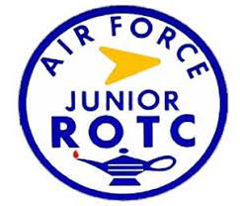
AFJROTC Patch Knowledge
Lamp: Knowledge
Red: Blood of life
White: Daylight
Blue: The sky
Yellow: The sun
Arrow: The Future

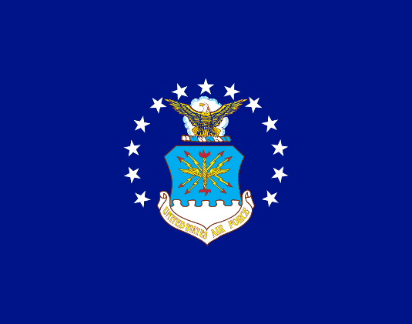
Air Force Flag
Adopted: March 26, 1951
Designer: Dorothy G. Gatchell
Stars: 13 total, three star grouping to portray the three major DoDs (Army, Navy, Air Force)
Represents the transition from the Army Air Corps to its own branch

Chain of Command
Top Three (Local)
Position | Title | Name
Group Commander | C/Lt. Col. | Angel Loor
Deputy Commander | C/Maj. | Sidhartha Gudipati
Chief | C/CMSgt | Noah Perez
National (Top 5)
Position | Title | Name
Commander in Chief | The Honorable | Donald J. Trump
Vice President | The Honorable | JD Vance
Secretary of Defense | The Honorable | Pete Hegseth
Secretary of the Air Force | The Honorable | Dr. Troy E. Meink
Secretary of State | The Honorable | Marco Rubio
National
Position | Title | Name
Speaker of the House | The Speaker | Mike Johnson
Chairman of the Joint Chiefs of Staff | General | Dan Caine
Chief of Staff of the Air Force | General | Kenneth S. Wilsbach
Commander of Air Education and Training Command (AETC) | Lieutenant General | Clark J. Quinn
Commander of Air University | Lieutenant General | Daniel H. Tulley
Commander of Holm Center | Brigadier General | Joseph L. Sheffield
Director of AFJROTC | Lieutenant Colonel | Matthew E. Tipton
Chief Master Sergeant of the Air Force | Chief Master Sergeant | David R. Wolfe

AFJROTC Ranks
Cadet Enlisted
E-1 | E-2 | E-3 | E-4 | E-5
No insignia | 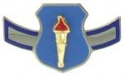 | 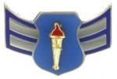 | 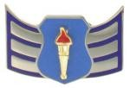 | 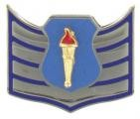
Cadet Airman basic  (C/AB) | Cadet Airman  (C/Amn) | Cadet Airman First Class  (C/A1C) | Cadet Senior Airman  (C/SrA) | Cadet Staff Sergeant  (C/SSgt)
E-6 | E-7 | E-8 | E-9 | E-10
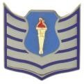 | 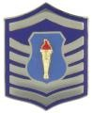 | 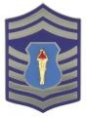 | 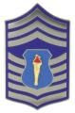 | AFJROTC ranks stop here
Cadet Technical Sergeant  (C/TSgt) | Cadet Master Sergeant  (C/MSgt) | Cadet Senior Master Sergeant  (C/SMSgt) | Cadet Chief Master Sergeant  (C/CMSgt) | AFJROTC ranks stop here

Cadet Officer
O-1 | O-2 | O-3 | O-4 | O-5 | O-6
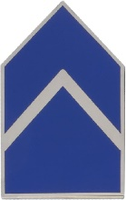 | 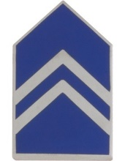 | 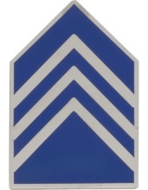 | 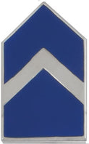 | 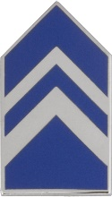 | 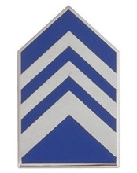
Cadet Second Lieutenant  (C/2d Lt.) | Cadet First Lieutenant  (C/1st Lt.) | Cadet Captain  (C/Capt.) | Cadet Major  (C/Maj.) | Cadet Lieutenant Colonel  (C/Lt. Col.) | Cadet Colonel  (C/Col.)

Air Force Ranks
E-1 | E-2 |  | E-3 |  | E-4 |  | E-5
No insignia |  |  |  |  |  |  | 
Airman Basic  (AB) | Airman  (Amn) |  | Airman First Class  (A1C) |  | Senior Airman  (SrA) |  | Staff Sergeant  (SSgt)
E-6 |  | E-7 |  | E-8 |  | E-9
 |  |  |  |  |  | 
Technical Sergeant  (TSgt) |  | Master Sergeant  (MSgt) |  | Senior Master Sergeant  (SMSgt) |  | Chief Master Sergeant  (CMSgt)
Enlisted

Officer
O-1 | O-2 | O-3 |  | O-4 |  | O-5 |  | O-6
 |  |  |  |  |  |  |  | 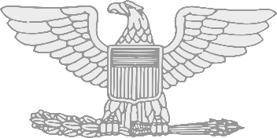
Second Lieutenant  (2d Lt) | First Lieutenant  (1st Lt) | Captain  (Capt) |  | Major  (Maj) |  | Lieutenant Colonel  (Lt Col) |  | Colonel  (Col)
O-7 |  |  | O-8 |  |  |  | O-9
 |  |  |  |  |  |  | 
Brigadier General  (Brig Gen) |  |  | Major General  (Maj Gen) |  |  |  | Lieutenant General  (Lt Gen)
O-10 |  |  |  |  | Special
 |  |  |  |  | 
General  (Gen) |  |  |  |  | General of the Air Force  (Gen-USAF)
General Orders
- I will take charge of my post and protect personnel and property for which I am responsible, until properly relieved.
- I will report all violations of orders that I am entrusted to enforce and call my superior in any case not covered by instructions.
- I will sound the alarm in any case of disorder or emergency.

30 Step Drill Sequence:
- Flight, fall in  - Open ranks, MARCH  - Ready front  - Closed ranks, MARCH  - Present arms  - Order arms  - Parade rest  - Attention  - Left face  - About face  - Forward, MARCH  - Right flank, MARCH  - Left flank, MARCH  - Column right, MARCH  - Forward, MARCH | - To the rear, MARCH  - To the rear, MARCH  - Column right, MARCH  - Forward, MARCH  - Eyes right  - Ready front  - Column right, MARCH  - Forward, MARCH  - Change step, MARCH  - Column right, MARCH  - Forward, MARCH  - Flight, HALT  - Left face  - Right step, MARCH  - Flight HALT

Left foot  - Left Flank  - Column left  - Eyes, left  - Forward | Right foot  - Right flank  - Column right  - Eyes, right  - To the rear  - Change step
Both/ Any
- Double time
- Mark time
- Halt

AFJROTC Cadet Creed
I am an Air Force Junior ROTC Cadet.
I am connected and faithful to every Corps of Cadets who serve their community and nation with patriotism.
I earn respect when I uphold the Core Values of Integrity First, Service Before Self, and Excellence In All We Do.
I will always conduct myself to bring credit to my family, school, Corps of Cadets, community, and to myself.
My character defines me. I will not lie, cheat, or steal. I am accountable for my actions and deeds.
I will hold others accountable for their actions as well. I will honor those I serve with, those who have gone before me, and those who will come after me.
I am a Patriot, a Leader, and a Wingman devoted to those I follow, serve, and lead.
I am an Air Force Junior ROTC Cadet

The Air Force Song
Off we go into the wild blue yonder,
Climbing high into the sun;
Here they come zooming to meet our thunder,
At 'em now, Give ‘em the gun!
Down we dive, spouting our flame from under,
Off with one helluva roar!
We live in fame or go down in flame. Hey!
Nothing'll stop the U.S. Air Force

