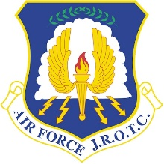**Unit General Knowledge Packet**

NATO Phonetic Alphabet 
A 
B 
C 
D 
F 
G 
H 
1 
J 
K 
L 
Alpha 
Bravo 
Charlie 
Delta 
Echo 
Foxtrot 
Golf 
Hotel 
India 
Juliett 
Kilo 
Lima 
Mike 
N 
0 
p 
Q 
R 
s 
T 
U 
V 
W 
X 
Y 
z 
November 
Oscar 
Pa a 
Quebec 
Romeo 
Sierra 
Tan o 
Uniform 
Victor 
Whiskey 
X-ra 
Yankee 
Zulu **Essential Knowledge**

AFJROTC: **A**ir **F**orce **J**unior **R**eserve **O**fficer **T**raining **C**orps

Air Force DoB: September 18, 1947

Air Force colors: Ultramarine blue and yellow

Air Force Mission Statement: To fly fight and win… airpower, anytime, anywhere!

Air Force Units: 3+ Cadet > 2+ Element > 2+ Flight > 2+ Squadron > 2+ Group > Wing > Numbered Air Force > Major Command

Uniform guidance: DAFI36-2903

The 6 Branches of the Military: Air Force, Army, Coast Guard, Marines, Navy, Space Force

Original 13 Colonies: Connecticut, Delaware, Georgia, New Hampshire, New Jersey, New York, North Carolina, Maryland, Massachusetts, Pennsylvania, Rhode Island, South Carolina, Virginia

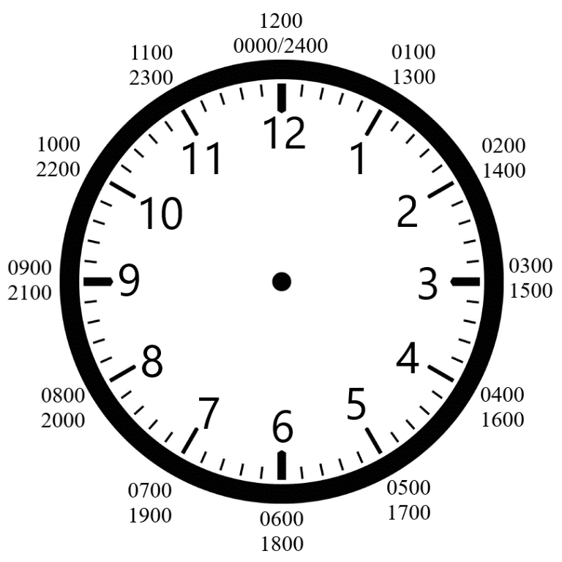Opening Statement: Sir/Ma’am good morning/afternoon sir/ma’am, cadet (rank and last name) is ready for inspection sir/ma’am!

The 7 Positions of Attention:

1. Eyes straight
2. Chin up
3. Chest out
4. Thumbs fixed to the seam of the pants
5. Heels Together
6. Feet at a 45-degree angle
7. Stand up straight

**AFJROTC Mission Statement:** To develop citizens of character dedicated to serving their nation and community.

**Core Values:** Integrity first, service before self, and excellence in all we do.

**Honor Code:** I will not lie, cheat, or steal; nor tolerate those among us who do.

**American Flag Knowledge**

Red: Hardiness and valor

Blue: Vigilance, perseverance, and justice

White: Purity and innocence

Stars: 50 white stars, one for each US state

Stripes: 13 total stripes for the 13 original colonies, 7 red stripes, 6 white stripes

First flag designer: Betsy Ross (Developed 1776)

Modern flag designer: Robert G. Heft (Developed 1958)

FOR 
JUNIOR 
ROTC**AFJROTC Patch Knowledge**

Lamp: Knowledge

Red: Blood of life

White: Daylight

Blue: The sky

Yellow: The sun

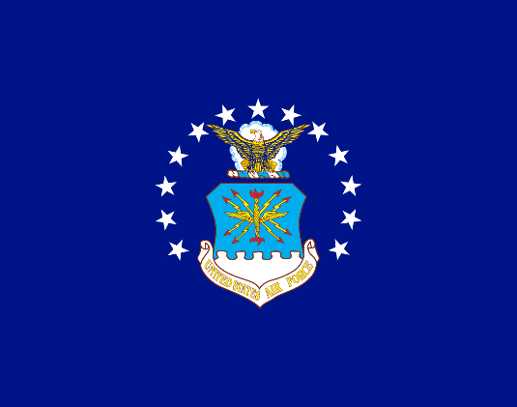**Air Force Flag**

Adopted: March 26, 1951

Designer: Dorothy G. Gatchell

Stars: 13 total, three star grouping to portray the three major DoDs (Army, Navy, Air Force)

Represents the transition from the Army Air Corps to its own branch

**Chain of Command**

Top Three (Local)

|  |  |  |
| --- | --- | --- |
| **Position** | **Title** | **Name** |
| Group Commander | C/Lt. Col. | Angel Loor |
| Deputy Commander | C/Maj. | Sidhartha Gudipati |
| Chief | C/CMSgt | Noah Perez |

National (Top 5)

|  |  |  |
| --- | --- | --- |
| **Position** | **Title** | **Name** |
| Commander in Chief | The Honorable | Donald J. Trump |
| Vice President | The Honorable | JD Vance |
| Secretary of Defense | The Honorable | Pete Hegseth |
| Secretary of the Air Force | The Honorable | Dr. Troy E. Meink |
| Secretary of State | The Honorable | Marco Rubio |

National

|  |  |  |
| --- | --- | --- |
| **Position** | **Title** | **Name** |
| Speaker of the House | The Speaker | Mike Johnson |
| Chairman of the Joint Chiefs of Staff | General | Dan Caine |
| Chief of Staff of the Air Force | General | David W. Allvin |
| Commander of Air Education and Training Command (AETC) | Lieutenant General | Brian S. Robinson |
| Commander of Air University | Lieutenant General | Andrea D. Tullos |
| Commander of Holm Center | Brigadier General | Houston R. Cantwell |
| Director of AFJROTC | Lieutenant Colonel | Matthew Tipton |
| Chief Master Sergeant of the Air Force | Chief Master Sergeant | David A. Flosi |

**AFJROTC Ranks**

Cadet Enlisted

|  |  |  |  |  |
| --- | --- | --- | --- | --- |
| **E-1** | **E-2** | **E-3** | **E-4** | **E-5** |
| No insignia |  |  |  |  |
| Cadet Airman basic  (C/AB) | Cadet Airman  (C/Amn) | Cadet Airman First Class  (C/A1C) | Cadet Senior Airman  (C/SrA) | Cadet Staff Sergeant  (C/SSgt) |
| **E-6** | **E-7** | **E-8** | **E-9** | **E-10** |
|  |  |  |  | AFJROTC ranks stop here |
| Cadet Technical Sergeant  (C/TSgt) | Cadet Master Sergeant  (C/MSgt) | Cadet Senior Master Sergeant  (C/SMSgt) | Cadet Chief Master Sergeant  (C/CMSgt) |

Cadet Officer

|  |  |  |  |  |  |
| --- | --- | --- | --- | --- | --- |
| **O-1** | **O-2** | **O-3** | **O-4** | **O-5** | **O-6** |
| Afjrotc Ranks | colegioclubuniversitario.edu.ar | SPRINGBORO HS AFJROTC CADET REQUIRED KNOWLEDGE Flashcards | Quizlet |  | AFJROTC Cadet Officer Rank - Metal Insignia - 1 Pair | AFJROTC Cadet Officer Rank, Lieutenant Colonel, Mini | AFJROTC Cadet Colonel (C-COL) – Mil-Bar |
| Cadet Second Lieutenant  (C/2d Lt.) | Cadet First Lieutenant  (C/1st Lt.) | Cadet Captain  (C/Capt.) | Cadet Major  (C/Maj.) | Cadet Lieutenant Colonel  (C/Lt. Col.) | Cadet Colonel  (C/Col.) |

**Air Force Ranks**

|  |  |  |  |  |  |  |  |
| --- | --- | --- | --- | --- | --- | --- | --- |
| **E-1** | **E-2** | | **E-3** | | **E-4** | | **E-5** |
| No insignia |  | |  | |  | |  |
| Airman Basic  (AB) | Airman  (Amn) | | Airman First Class  (A1C) | | Senior Airman  (SrA) | | Staff Sergeant  (SSgt) |
| **E-6** | | **E-7** | | **E-8** | | **E-9** | |
|  | |  | |  | |  | |
| Technical Sergeant  (TSgt) | | Master Sergeant  (MSgt) | | Senior Master Sergeant  (SMSgt) | | Chief Master Sergeant  (CMSgt) | |

Enlisted

Officer

|  |  |  |  |  |  |  |  |  |
| --- | --- | --- | --- | --- | --- | --- | --- | --- |
| **O-1** | **O-2** | **O-3** | | **O-4** | | **O-5** | | **O-6** |
|  |  |  | |  | |  | |  |
| Second Lieutenant  (2d Lt) | First Lieutenant  (1st Lt) | Captain  (Capt) | | Major  (Maj) | | Lieutenant Colonel  (Lt Col) | | Colonel  (Col) |
| **O-7** | | | **O-8** | | | | **O-9** | |
|  | | |  | | | |  | |
| Brigadier General  (Brig Gen) | | | Major General  (Maj Gen) | | | | Lieutenant General  (Lt Gen) | |
| **O-10** | | | | | **Special** | | | |
|  | | | | |  | | | |
| General  (Gen) | | | | | General of the Air Force  (Gen-USAF) | | | |

**General Orders**

1. I will take charge of my post and protect personnel and property for which I am responsible, until properly relieved.
2. I will report all violations of orders that I am entrusted to enforce and call my superior in any case not covered by instructions.
3. I will sound the alarm in any case of disorder or emergency.

|  |  |
| --- | --- |
| **30 Step Drill Sequence:** | |
| 1. Flight, fall in 2. Open ranks, MARCH 3. Ready front 4. Closed ranks, MARCH 5. Present arms 6. Order arms 7. Parade rest 8. Attention 9. Left face 10. About face 11. Forward, MARCH 12. Right flank, MARCH 13. Left flank, MARCH 14. Column right, MARCH 15. Forward, MARCH | 1. To the rear, MARCH 2. To the rear, MARCH 3. Column right, MARCH 4. Forward, MARCH 5. Eyes right 6. Ready front 7. Column right, MARCH 8. Forward, MARCH 9. Change step, MARCH 10. Column right, MARCH 11. Forward, MARCH 12. Flight, HALT 13. Left face 14. Right step, MARCH 15. Flight HALT |

|  |  |
| --- | --- |
| **Left foot**   1. Left Flank 2. Column left 3. Eyes, left 4. Forward | **Right foot**   1. Right flank 2. Column right 3. Eyes, right 4. To the rear 5. Change step |
| **Both/ Any**   1. Double time 2. Mark time 3. Halt | |

**AFJROTC Cadet Creed**

I am an Air Force Junior ROTC Cadet.

I am connected and faithful to every Corps of Cadets who serve their community and nation with patriotism.

I earn respect when I uphold the Core Values of Integrity First, Service Before Self, and Excellence In All We Do.

I will always conduct myself to bring credit to my family, school, Corps of Cadets, community, and to myself.

My character defines me. I will not lie, cheat, or steal. I am accountable for my actions and deeds.

I will hold others accountable for their actions as well. I will honor those I serve with, those who have gone before me, and those who will come after me.

I am a Patriot, a Leader, and a Wingman devoted to those I follow, serve, and lead.

I am an Air Force Junior ROTC Cadet

**The Air Force Song**

Off we go into the wild blue yonder,

Climbing high into the sun;

Here they come zooming to meet our thunder,

At 'em now, Give ‘em the gun!

Down we dive, spouting our flame from under,

Off with one helluva roar!

We live in fame or go down in flame. Hey!

Nothing'll stop the U.S. Air Force